**Wealth management operations**

After decades advising some of the wealthiest and most famous clients, we have a completely new mission: to transform the way money is managed for those who could benefit the most from everything we have learned over the years.

The average salary for a wealth manager in the United States in 2024 was $134,900.

As of 2024, it is estimated that the wealth management industry had AUM of upwards of $128.9 trillion globally. This figure is expected to grow to $145.4 trillion by the year 2025.

Most wealth management firms tend to work with ultra-wealthy clients. This means these financial institutions tend to seek out and service clients who have at least $250,000 to $500,000 in assets and higher.

**Financial Planning Services**

**Investment Management**

We can help you build a diversified portfolio that meets your risk tolerance and investment objectives.

**Estate Planning**

We can help you preserve your assets and ensure that your wishes are carried out after your death.

**Retirement Planning**

We can help you create a retirement plan that will help you work toward your retirement goals.

**Tax Minimization**

Our goal is to help you minimize your taxes and maximize your after-tax income.

Wealth management operations in the USA involve providing personalized financial services and investment advice to high-net-worth individuals (HNWIs) and affluent families.

**Client Segmentation**

Wealth management firms categorize clients based on their wealth levels, with categories such as mass affluent, high-net-worth (HNW), and ultra-high-net-worth (UHNW).

According to a report by Cerulli Associates, as of 2021, there were approximately 13.1 million HNW households in the USA, representing around 10% of all U.S. households.

**Investment Advisory Services**

Wealth managers offer investment advice and portfolio management services tailored to clients' financial goals, risk tolerance, and time horizon.

The total assets under management (AUM) by registered investment advisors (RIAs) in the USA reached $118.9 trillion in 2021, as reported by the Investment Adviser Association (IAA).

**Financial Planning**

Includes services such as retirement planning, estate planning, tax planning, and education planning.

A survey by the Certified Financial Planner Board of Standards (CFP Board) found that 68% of CFP professionals in the USA provide comprehensive financial planning services.

**Alternative Investments**

Wealth managers offer access to alternative investments such as private equity, hedge funds, real estate, and structured products.

According to Preqin, alternative assets under management in North America reached $4.4 trillion in 2021, with strong interest from HNWIs and institutional investors.

**Wealth Transfer and Philanthropy**

Wealth management firms assist clients in estate planning, succession planning, and charitable giving strategies.

The National Philanthropic Trust (NPT) reports that charitable giving by individuals, foundations, and corporations in the USA totaled $471.44 billion in 2020.

**Technology and Digital Transformation**

Wealth managers leverage technology such as robo-advisors, digital platforms, and data analytics for client engagement and operational efficiency.

A report by Deloitte found that 67% of wealth management firms in North America are investing in digital transformation initiatives.

**Regulatory Compliance**

Wealth management operations are subject to regulatory oversight from agencies such as the Securities and Exchange Commission (SEC) and the Financial Industry Regulatory Authority (FINRA).

Compliance costs for wealth management firms in the USA have been rising, with estimates ranging from thousands to millions of dollars annually per firm.

These data points highlight the size and complexity of wealth management operations in the USA, as well as the diverse range of services offered to affluent clients.

**Treasury management services**

Efficiently manage cash flow and liquidity, coordinate access for multiple users, and monitor accounts for fraud.

Easily manage your payables and receivables with our Treasury connectivity solutions that bring strategy and opportunity together. U.S. Bank connectivity tools bring you closer to your customers.

Treasury management is the act of managing a company’s daily cash flows and larger-scale decisions when it comes to finances. It can provide governance over a company's liquidity, establish and maintain credit lines, optimize investment returns, and strategize the best use of funds. As a company raises, earns, or uses cash, treasurers or senior financial officers ensure that there is working capital to maintain operations and reduce financial risks.

Treasury management services in the USA encompass a range of financial services and strategies designed to help businesses efficiently manage their cash, liquidity, and financial risks. These services are often provided by banks and financial institutions to corporate clients.

**Cash Management**

Involves optimizing cash flows, managing collections and disbursements, and minimizing idle cash.

According to a survey by the Association for Financial Professionals (AFP), 62% of organizations in 2022 reported using electronic payment methods for their cash management needs.

**Liquidity Management**

Focuses on ensuring that businesses have adequate liquidity to meet short-term obligations.

The Federal Reserve's data shows that the total value of commercial and industrial loans in the USA reached $2.5 trillion in Q1 2024, indicating the need for effective liquidity management.

**Working Capital Solutions**

Includes services such as trade finance, supply chain financing, and inventory management.

A study by Ernst & Young found that 67% of companies in the USA are actively pursuing working capital optimization strategies.

**Risk Management**

Involves hedging against currency risk, interest rate risk, and commodity price risk.

According to the Bank for International Settlements (BIS), the notional value of over-the-counter (OTC) derivatives outstanding in the USA stood at $501 trillion in 2021, highlighting the importance of risk management tools.

**Investment Management**

Focuses on optimizing returns on excess cash through investments in money market instruments, bonds, and other financial assets.

The Investment Company Institute (ICI) reports that money market fund assets in the USA totaled $4.5 trillion as of May 2024, indicating a significant portion of corporate cash being managed in such funds.

**Technology and Automation**

Utilizes technology such as treasury management systems (TMS), artificial intelligence (AI), and blockchain for efficient cash and risk management.

A survey by Deloitte found that 82% of treasury professionals believe that technology will significantly impact treasury operations in the coming years.

**Compliance and Regulatory Management**

Ensures compliance with financial regulations and industry standards such as the Sarbanes-Oxley Act (SOX) and the Payment Card Industry Data Security Standard (PCI DSS).

The cost of compliance for financial institutions in the USA is substantial, with estimates ranging from hundreds of millions to billions of dollars annually.

These data points illustrate the diverse range of treasury management services offered in the USA and the importance of effective cash, liquidity, and risk management for businesses across various industries.

**Risk management in banking operations**

Banking risk management is the process of a bank identifying, evaluating, and taking steps to mitigate the chance of something bad happening from its operational or investment decisions. This is especially important in banking, as banks are responsible for creating and managing money for others.

**Types of Risk Management in Banking**

There are several types of risk management in banking:-

**Credit Risk Management**

This involves assessing the creditworthiness of borrowers and managing the risk of default. Banks use various techniques, such as credit scoring models and credit analysis, to evaluate the credit risk of potential borrowers.

According to the Federal Reserve's latest data, as of Q1 2024, the delinquency rate for all loans and leases in commercial banks was 1.14%.

**Market Risk Management**

This involves managing the risk of losses due to changes in market conditions, such as interest rates, exchange rates, and commodity prices. Banks use various risk management tools, such as derivatives and hedging strategies, to manage market risk.

The OCC's data shows that interest rate risk is a significant concern for banks, especially as rates change.

**Operational Risk Management**

This involves managing the risk of losses due to inadequate or failed internal processes, people, and systems, as well as external events. Banks use various techniques, such as risk assessment and control frameworks, to manage operational risk.

According to a report by Deloitte, operational risk accounts for around 20-30% of all banking losses globally.

**Liquidity Risk Management**

This involves managing the risk of not being able to meet financial obligations when they become due. Banks use various liquidity management techniques, such as cash flow forecasting and stress testing, to manage liquidity risk.

The Federal Reserve conducts stress tests to assess banks' ability to withstand liquidity shocks.

As of the latest stress test results, major banks have sufficient liquidity buffers to withstand severe economic downturns.

**Reputational Risk Management**

This involves managing the risk of negative publicity and damage to the bank’s reputation due to its actions or those of its employees. Banks use various techniques, such as corporate governance and compliance frameworks, to manage reputational risk.

**The risk management process in banking typically involves six components:-**

**Identification:** Defining the nature of risks, including where they originate from and why they pose a threat to the bank.

**Assessment and Analysis:** Evaluating how likely a risk will pose a threat to the bank, and how grave that threat will likely be. This helps a bank prioritize which risks deserve the most attention.

**Mitigation:** Designing and implementing bank policies and processes that limit the chance that risks will become threats, and that minimize the damage threats may cause.

**Monitoring:** Gathering data on threat prevention and incident response to determine how well a bank risk management strategy is working. This also involves researching emerging risk trends to determine if a bank’s risk management framework needs (or will need) updating.

**Cooperation:** Establishing relationships between risks and mitigation strategies across different areas of the bank’s operations to create a more centralized and coordinated threat response system.

**Reporting:** Documenting and reviewing information related to the bank’s risk management efforts to gauge their effectiveness. This is also used to track how the bank’s overall risk profile changes over time.

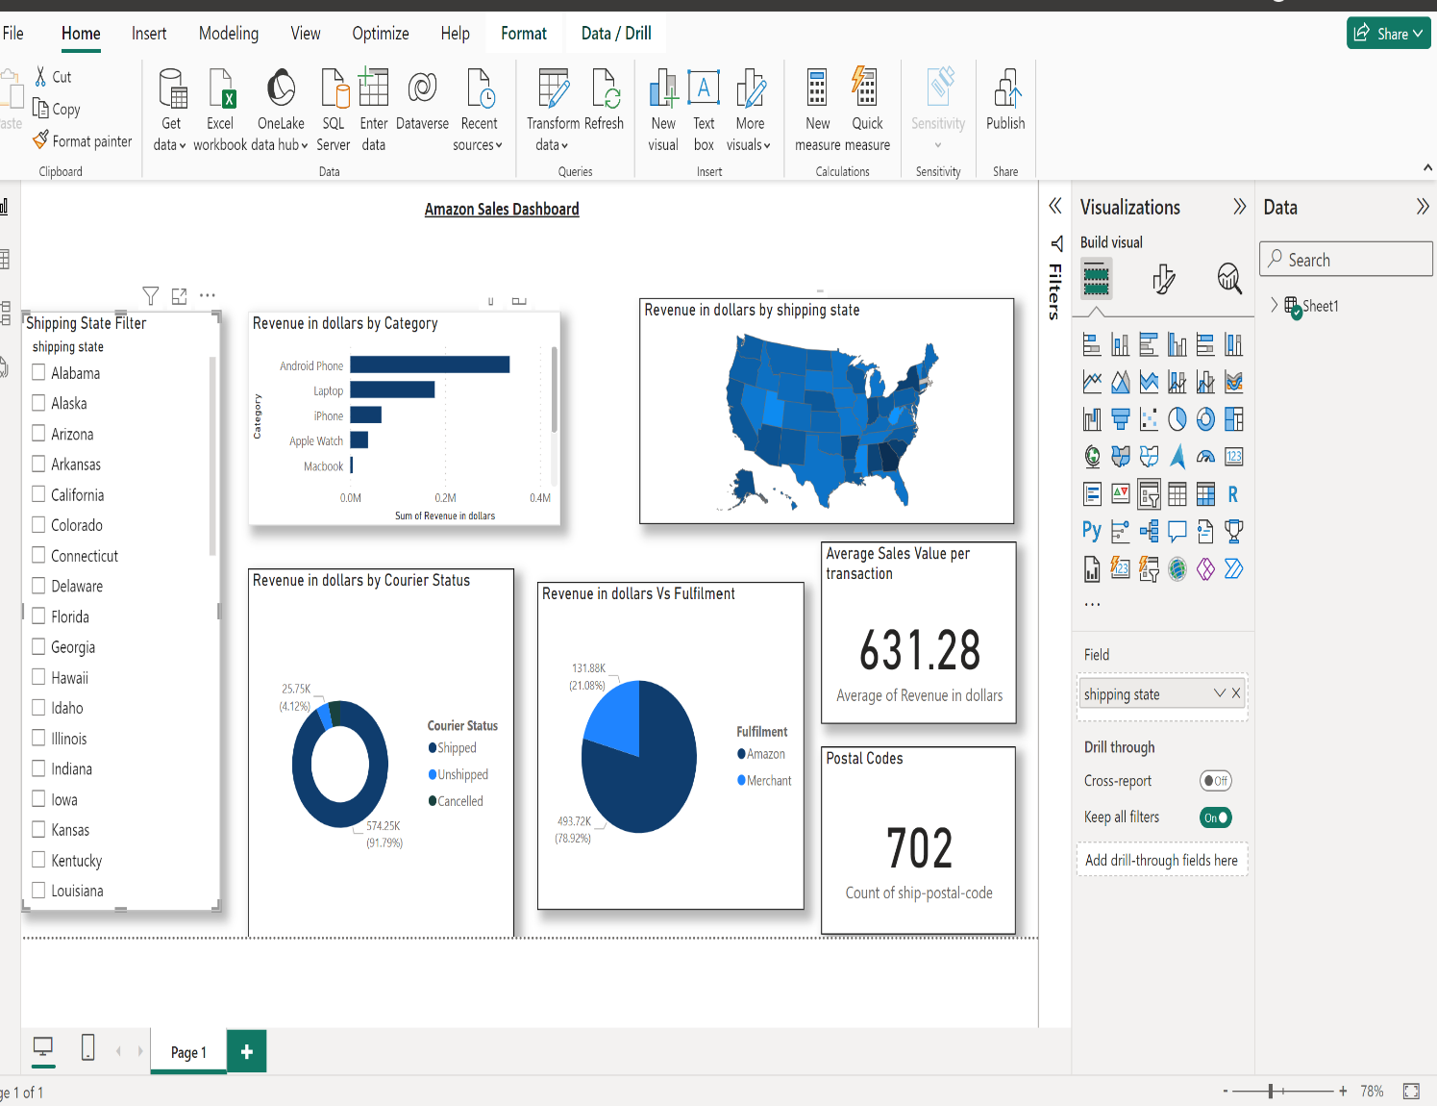

I downloaded data from Amazon and used it to create a dashboard in Power BI.